BUG REPORT

BUG ID: BUG-001
SUMMARY: LOGIN IS SUCCESSFUL WHEN AN INVALID PASSWORD IS ENTERED
ENVIRONMENT: Operating System: Windows 11
Browser: Google Chrome (Latest Version)

STEPS TO REPRODUCE:
1. Open the Login Page
2. Enter a Valid Username
3. Enter an Incorrect Password
4. Click the “Login” button

EXPECTED RESULT: The system should reject the login attempt and display an "Invalid username or password" error message.
ACTUAL RESULT: The application displays "Login Successful" and grants access despite the incorrect password.

SCREENSHOT:
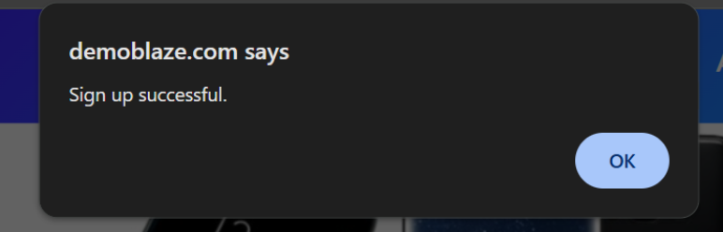

SEVERITY: Critical

PRIORITY: High

BUG ID: BUG-002
SUMMARY: PASSWORD ENTERED IN THE LOGIN FORM IS DISPLAYED IN PLAIN TEXT INSTEAD OF BEING MASKED
ENVIRONMENT: Operating System: Windows 11
Browser: Google Chrome (Latest Version)

STEPS TO REPRODUCE:
1. Open the Login Page
2. Click inside the Password field
3. Enter any Password

EXPECTED RESULT: The password should be hidden using masking characters (e.g., ●●●●● or ****)
ACTUAL RESULT: The password is displayed in plain text and is visible on the screen.

SCREENSHOT:
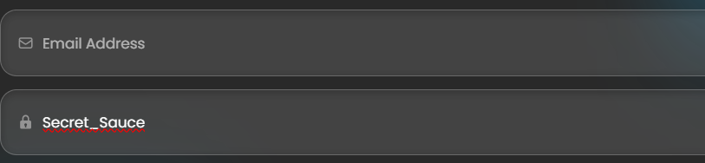

SEVERITY: Major

PRIORITY: High

BUG ID: BUG-003
SUMMARY: THE LOGIN BUTTON REMAINS ACTIVE WHILE THE LOGIN REQUEST IS PROCESSING
ENVIRONMENT: Operating System: Windows 11
Browser: Google Chrome (Latest Version)

STEPS TO REPRODUCE:
1. Open the Login Page
2. Enter Valid Login Credentials
3. Click the Login button repeatedly before the request completes

EXPECTED RESULT: The Login button should become disabled or display a loading indicator until the request has finished.
ACTUAL RESULT: The Login button remains active, allowing multiple clicks and duplicate login requests.

SCREENSHOT:
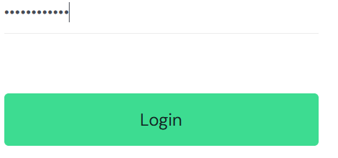

SEVERITY: Medium

PRIORITY: Medium

